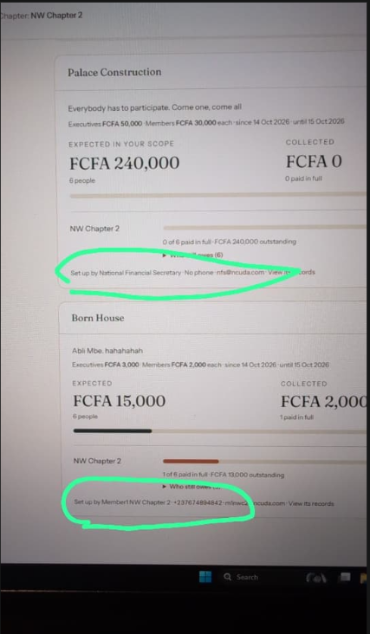
Figure 1 Set up by "post that set it up" (eg Buea FS) - phone – email – View records

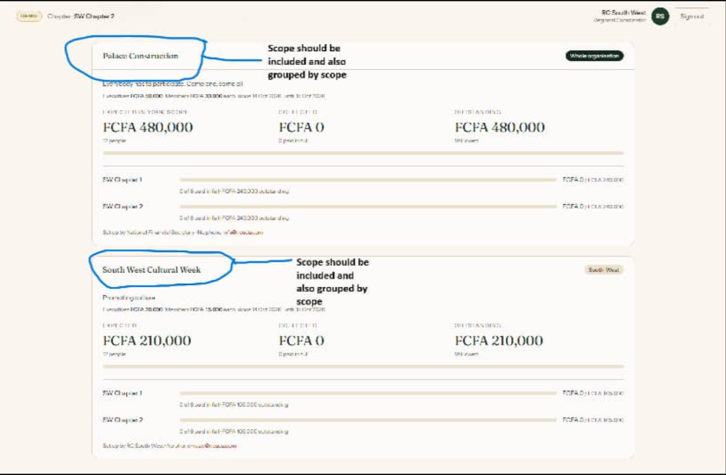
Figure 2 Projects under Contribution page should be grouped by scope (that is Whole Organisation, Regional, Chapter). When each is clicked, it should show the corresponding project using the last modified format (that is the newest projects on top)

1) Sorting of members should be done like so:
- Executives by rank (president, vice president, secretary, financial secretary, treasurer, socials)
- Ordinary Members by alphabetic order
- In a case were a an ordinary member in a chapter has an executive post at the National level, when the chapter executives want to view members, chapter executives come first in the order above, then the national executive before ordinary members in alphabetical order.

2) I've noticed that the National FS is expected to pay all contributions which shouldn't be so. If it is not in her designated chapter, region or is not organization-wide, she shouldn't have to pay.
3) Vice Presidents should have all the permissions of their corresponding presidents.

